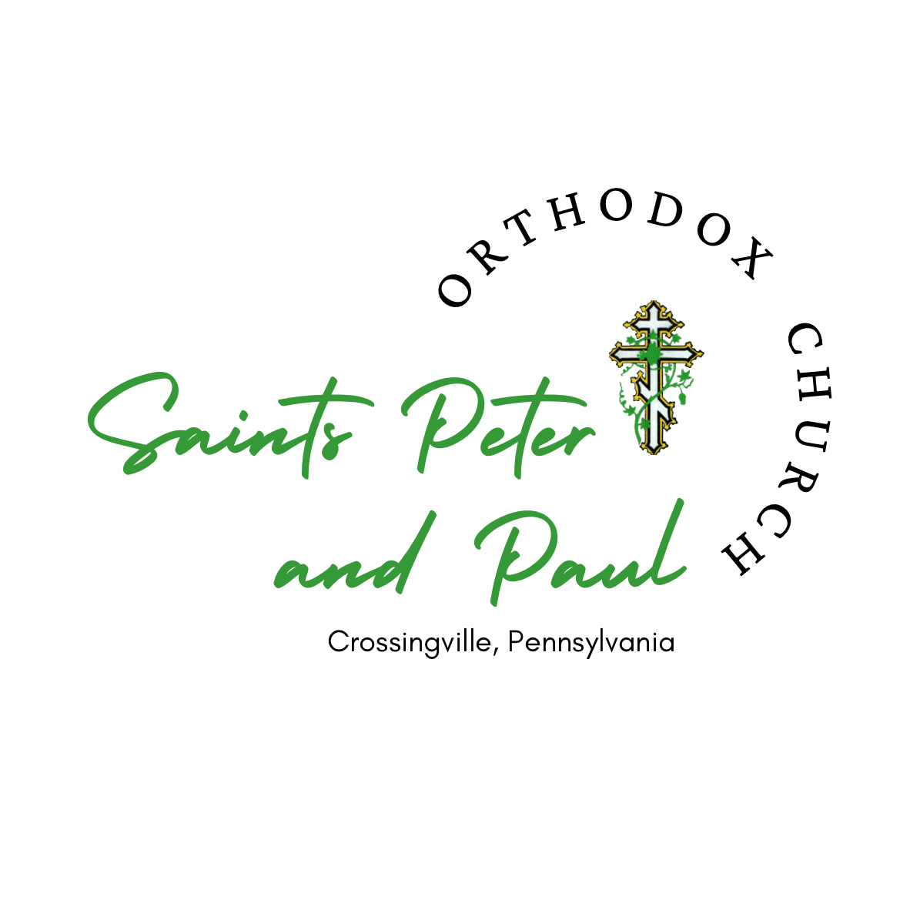

May 15, 2022

Dear Brothers and Sisters in Christ,

Christ is Risen! Indeed He is Risen!

We would like to thank you for any encouraging thoughts, prayers, or support you may have sent us at Saints Peter and Paul Orthodox Church in Crossingville, Pennsylvania this past year in honor of our 100th Anniversary. To celebrate, we hosted an Open House on July 31, 2021 for our local community to “come and see”. The following day, Archbishop Melchisedek, along with many friends and family, joined us for the Divine Liturgy and a luncheon afterwards. The entire weekend was a blessed and joyous occasion that we were grateful to have, especially during such uncertain times. We are most excited to report that since then, our parish has grown and Fr. Daniel has chrismated eight new members into the Orthodox Faith! Glory be to Jesus Christ!

The Open House was so enjoyable and such a success that our Missions and Outreach Ministry decided to make it an annual community event. This year our Open House will be on Saturday, July 30, 2022 from 12-4pm. It will include church and atrium tours, live performances, local vendors, a bounce house, a pet blessing, games and activities, a bake sale, food and drink concessions, and more. We hope you can join us!

By the grace of God, our community outreach throughout the year doesn’t stop there. We host or participate in several different events to help spread the Good News of the Gospel of Jesus Christ. We humbly ask for your continued prayers and support to help grow and preserve our parish for future generations.

If you are interested in becoming a sponsor of our upcoming Open House, please see the enclosed forms. For the most recent information on our parish and the event, please visit our website at www.orthodoxcrossingville.org. We are eternally grateful for your continued prayers and generosity!

Yours in Christ,

Rev. Daniel Mathewson Katya Hill Anna Rachocki
Priest Parish Council Missions & Outreach
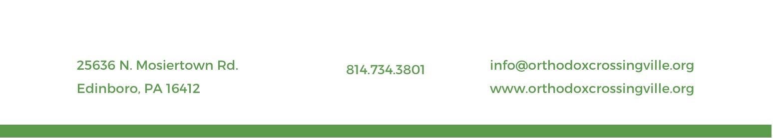
President Chairperson

Open House 2022 Sponsorship Opportunities

Supporting Sponsor - $25.00
Your name or business listed in our Sunday Bulletin.

Contributing Sponsor - $50.00
Your name or business listed on our website and in our Sunday Bulletin.

Major Sponsor - $100.00
Your name or business listed on our social media sites, website, and in our Sunday Bulletin.

Entertainment Sponsor - $150.00 (3 available)
Your name or business displayed near the entertainment, on our social media sites, website, and in our Sunday Bulletin.

Tent Sponsor - $350.00 (1 available)
Your name or business displayed near the tent, on our social media sites, website, and in our Sunday Bulletin.

Kid Zone Sponsor - $400.00 (1 available)
Your name or business displayed near the Kid Zone, on our social media sites, website, and in our Sunday Bulletin.

Full Media Sponsor - $1000.00
Your name or business displayed on all flyers distributed in person, online, and all media advertisements, as well as at the event, on our social media sites, website, and in our Sunday Bulletin.

You can send your donation online via PayPal to https://www.paypalme/ssppcrossingville, along with your display name, address, and sponsorship level and amount. If you wish to avoid fees, please send via “friends and family”. You can also mail your check donation and the following form to:

Sts. Peter and Paul Orthodox Church
25636 N. Mosiertown Rd.
Edinboro, PA 16412

Please note the deadline to submit information is June 30, 2022. Your donation is greatly appreciated! Sponsorships will be prioritized as we receive them. Sts. Peter and Paul Orthodox Church has the right to move your sponsorship to a different placement if your preferred placement has already been reserved. We will notify you of any changes.
Sts. Peter and Paul Orthodox Church is authorized to use the following name or business logo for its Open House media and materials:

Sponsor Name:

Display Name (if different):

Address (for tax purposes only):

Phone:

Email:

Date:

Sponsorship Level & Amount:

